A multi-marker environmental DNA metabarcoding baseline of plankton diversity in two contrasting Brahmaputra floodplain wetlands: the Ramsar site Deepor Beel and the reference wetland Chandubi Beel, Assam, India
Sahil Seikh
Department of Zoology, B. Borooah College (Autonomous), Guwahati, Assam, India
Correspondence: sahilseikh132@gmail.com

Working draft. This is a descriptive baseline built from a single water sample per wetland for each of two markers (COI and 18S rRNA). With one sample per site, between-site differences are reported as patterns, not as statistically tested effects; no inferential tests are applied. Placeholders for co-authors, funding, acknowledgements and Eurofins methods detail are marked [ ]. Three regional Deepor Beel references need bibliographic verification before submission (see end).

Abstract
Wetland plankton respond quickly to changes in water quality, which makes them useful sentinels of ecological condition. Morphological identification of these communities is slow and misses small or soft-bodied taxa, so DNA-based approaches are increasingly used to complement it. Here I characterise the plankton of two floodplain wetlands of the Brahmaputra valley in Assam, northeast India, using environmental DNA metabarcoding of two markers: a mitochondrial COI fragment for metazoan zooplankton and the 18S rRNA V4 region for the wider micro-eukaryote assemblage, including phytoplankton and protists. Deepor Beel is a Ramsar site under sustained anthropogenic pressure; Chandubi Beel, less disturbed, serves as a reference. One surface-water sample per wetland was sequenced on Illumina and processed into amplicon sequence variants (ASVs) in QIIME 2. COI recovered 169 ASVs at Chandubi and 105 at Deepor; 18S recovered 321 and 102. Both markers were dominated by a small number of taxa but retained even, diverse tails (COI Shannon 4.48 and 4.23; 18S 4.91 and 4.01). The two markers told different halves of the same story. Zooplankton assemblages shared their core rotifers across both wetlands (eight named species in common; Bray–Curtis dissimilarity 0.22), yet the eutrophy-associated Keratella tropica and Brachionus caudatus together rose from 11% of reads at Chandubi to 25% at Deepor. The micro-eukaryote assemblages, by contrast, barely overlapped (two named species in common; Bray–Curtis 0.77): Chandubi carried a green-algal and diatom signal (photoautotrophs 25% of reads), whereas Deepor was dominated by heterotrophs — nematodes, gastrotrichs, fungi and oomycetes (metazoa 41%, fungi 18%, algae only 10%). Copepods and cladocerans were absent from the COI-identified fraction, a reference-database gap rather than a true absence, since 18S recovered the copepod Mesocyclops dissimilis. The results give a first molecular inventory for both wetlands and a defensible baseline against which seasonal or replicated sampling can later test the differences quantitatively.
Keywords: eDNA metabarcoding; zooplankton; micro-eukaryotes; COI; 18S rRNA; Deepor Beel; Chandubi Beel; Ramsar wetland; rotifers; biomonitoring

1. Introduction
Plankton sit at the base of wetland food webs and turn over fast, so their composition tracks nutrient status, organic loading and hydrological change on a scale of weeks. That sensitivity is exactly what makes them useful for biomonitoring. The practical obstacle has always been identification: rotifers, small crustaceans, ciliates and algae demand different preparation and expertise, and the smallest or most fragile forms are routinely undercounted or lumped under coarse morphotypes.
Environmental DNA (eDNA) metabarcoding sidesteps much of that. A water sample yields DNA from the organisms suspended in it, and high-throughput sequencing of a taxonomically informative marker resolves the community in one assay (Sahu et al., 2025). No single marker sees everything, though. A mitochondrial cytochrome oxidase I (COI) fragment resolves metazoan zooplankton to species where reference coverage allows, but it does not amplify algae or most protists. The nuclear 18S rRNA gene captures the broader eukaryote assemblage — diatoms, green algae, dinoflagellates, ciliates, fungi — but often stops at coarser ranks. Studies that pair markers consistently recover more of the community than either alone (Zhang et al., 2018; Stefanni et al., 2018; Sildever et al., 2021; Zhao et al., 2021), which is the logic behind the two-marker design used here.
For freshwater plankton the eDNA literature is still thin outside a handful of well-studied systems, and thinner still for India (Sahu et al., 2025). Northeast India is a particular gap. The Brahmaputra floodplain holds hundreds of beels — shallow, seasonally connected wetlands — that are biologically rich and, in many cases, under mounting pressure from urban expansion, fisheries and pollution. Deepor Beel, on the southwestern edge of Guwahati, is the state's only Ramsar site and among its most pressured: it takes urban runoff and solid waste, and its margins have been progressively encroached. Chandubi Beel, farther from the city at the foot of the Garo hills, is comparatively undisturbed and offers a useful reference against which the Deepor community can be read.
This study establishes a molecular plankton baseline for the two wetlands and makes a first side-by-side comparison across two markers. The aim is deliberately modest and stated plainly: with a single sample per site, this is a descriptive inventory, not a test of what drives the differences. What it provides is a documented starting point — the taxa present, their relative read abundances, and where the two markers agree and diverge — that later replicated or seasonal sampling can build on.

2. Materials and Methods

2.1 Study sites and sampling
Two floodplain wetlands of the Brahmaputra basin in Kamrup district, Assam, were sampled: Deepor Beel (coded W2), a Ramsar site with documented nutrient loading and encroachment, and Chandubi Beel (W1), a relatively undisturbed reference wetland. One near-shore surface-water sample was collected from a single location in each beel. [Add sampling date, coordinates, depth, and volume filtered; filter type and pore size.] Physicochemical variables — pH, dissolved oxygen (Winkler), free CO₂, alkalinity, hardness, BOD, COD, dissolved organic matter, conductivity and nutrients — were measured alongside the biological sampling and will be integrated once replication allows the community–environment relationships to be tested. [Insert the measured water-quality values as a table.]

2.2 DNA extraction, markers and sequencing
Total DNA was extracted from each sample [add extraction kit and protocol]. Two marker regions were amplified. The metazoan community was targeted with the ~313 bp Leray COI fragment using mlCOIintF (Leray et al., 2013) with the degenerate dgHCO2198 reverse primer. The wider micro-eukaryote community was targeted with the 18S rRNA V4 region [add exact primer pair, e.g. E572F/E1009R; PCR conditions and cycle number]. Libraries were sequenced on an Illumina MiSeq (2 × 300 bp; run reported by the provider, Eurofins). Marker identity of the delivered COI dataset was confirmed directly from the reads by primer matching and by the presence of a single open reading frame under the invertebrate mitochondrial code, ruling out rRNA contamination.

2.3 Bioinformatics
Reads were processed in QIIME 2 with DADA2 denoising into amplicon sequence variants (ASVs); feature identifiers are MD5 hashes of the representative sequences. Taxonomy was assigned against a COI animal reference for the COI data and a SILVA-style eukaryote reference for 18S [confirm database names, versions, classifier and confidence threshold with the provider]. The two samples of each marker were denoised separately by the provider, so ASV identifiers are not directly comparable between samples; all between-site comparisons here were therefore made on the assigned taxonomy (genus and species), not on raw ASVs. Feature tables and per-sample taxonomy (Krona export) were the inputs to the analyses below.

2.4 Statistical analysis
All analyses were run in Python (pandas, NumPy, SciPy) on the ASV feature tables and the taxonomy tables. Per-sample alpha diversity was computed from the ASV counts as observed richness, the Shannon and Gini–Simpson indices, inverse Simpson, Pielou's evenness, the Berger–Parker dominance index, Chao1 and Good's coverage. Community composition was summarised as relative read abundance at phylum, genus and species rank. Taxon overlap between the two wetlands was quantified with the Jaccard index on named taxa, and compositional turnover with the Bray–Curtis and Morisita–Horn dissimilarities at genus level; because only one sample was available per site, these dissimilarities are reported as descriptors of the two profiles, not as tested effects. For the 18S data, phyla were grouped into broad functional categories (photoautotrophs, heterotrophic protists, fungi, metazoa) to summarise trophic structure. Read counts index relative, not absolute, abundance, and no significance testing was performed — the single-sample design does not support it.

3. Results

3.1 Sequencing effort and alpha diversity
The two markers returned uneven depth. COI yielded 69,975 reads in the final ASV table at Chandubi and 56,262 at Deepor; 18S yielded 23,633 and 11,274 (Table 1). Good's coverage reached 1.00 in every sample and Chao1 equalled observed richness, so the sampling captured essentially all of the diversity present in each library at these depths — deeper sequencing of the same samples would have added little. Richness was consistently higher at Chandubi: 169 versus 105 ASVs for COI, and 321 versus 102 for 18S. Both communities were dominated by a few taxa yet stayed even overall, with Shannon indices between 4.0 and 4.9 and Pielou's evenness above 0.85 throughout (Table 2, Figure 2). The sharpest contrast was in the 18S inverse Simpson index, which fell from 68.0 at Chandubi to 36.2 at Deepor — the Deepor micro-eukaryote community leaned more heavily on its dominant members.
Table 1. Sequencing yield and richness per marker and site (W1 = Chandubi Beel, W2 = Deepor Beel).
Marker | Site | Reads (ASV table) | ASVs | Total ASVs | Shared ASVs
COI | Chandubi (W1) | 69,975 | 169 | 272 | 2
COI | Deepor (W2) | 56,262 | 105
18S | Chandubi (W1) | 23,633 | 321 | 422 | 1
18S | Deepor (W2) | 11,274 | 102

Table 2. Alpha-diversity indices computed from the ASV feature tables.
Marker / Site | Observed ASVs | Shannon H′ | Inv. Simpson | Pielou J′ | Berger–Parker | Good's coverage
COI / Chandubi | 169 | 4.48 | 70.5 | 0.874 | 0.034 | 1.00
COI / Deepor | 105 | 4.23 | 60.2 | 0.909 | 0.030 | 1.00
18S / Chandubi | 321 | 4.91 | 68.0 | 0.851 | 0.058 | 1.00
18S / Deepor | 102 | 4.01 | 36.2 | 0.868 | 0.072 | 1.00
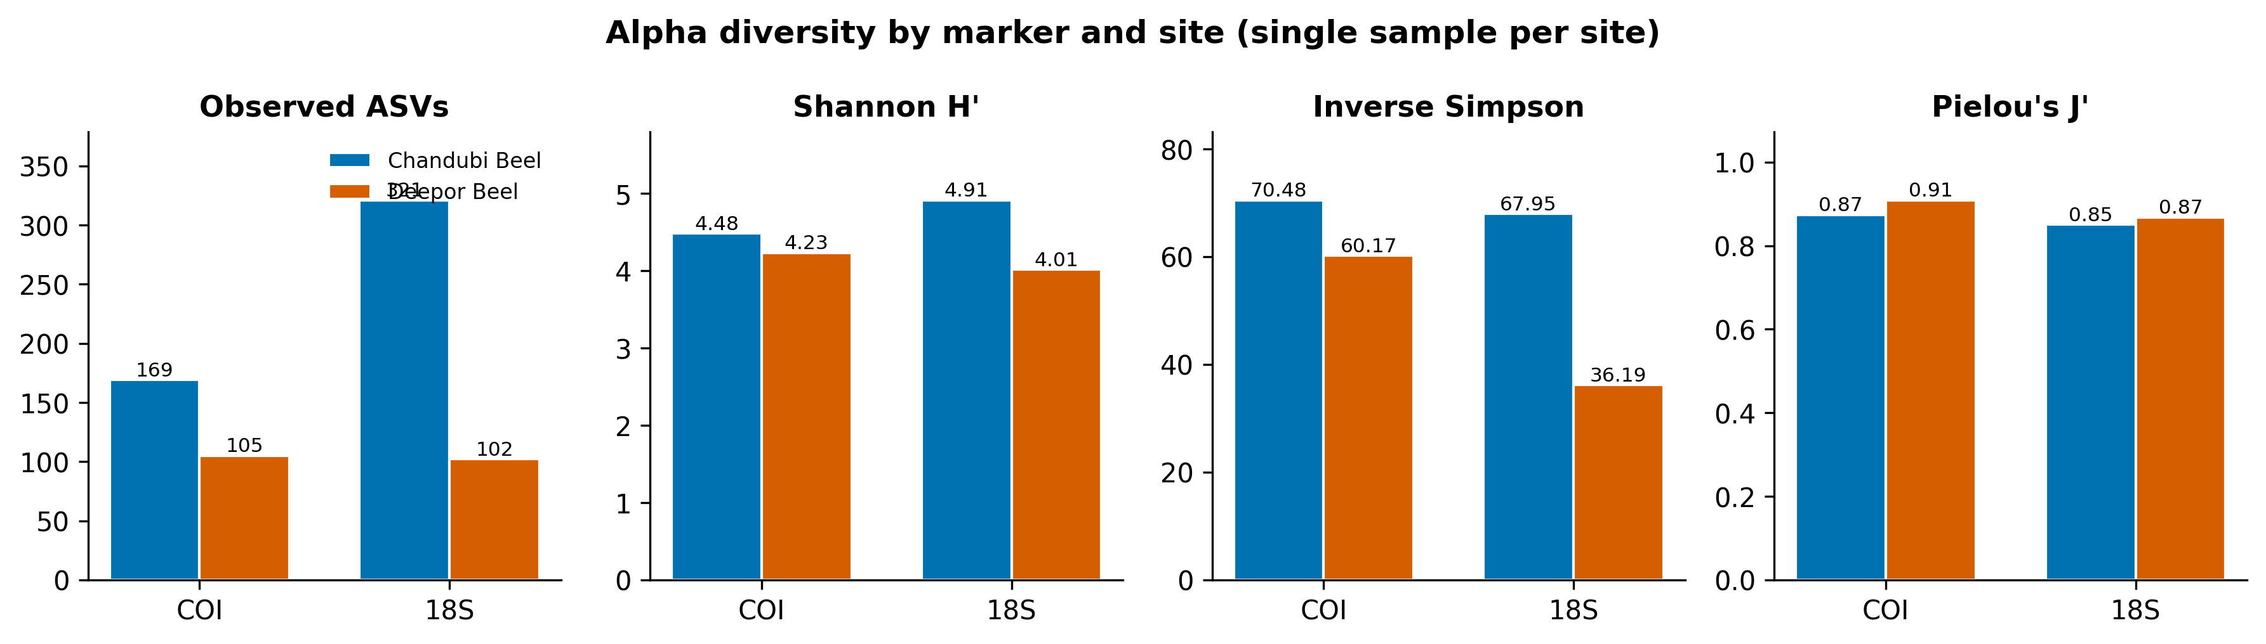
Figure 2. Alpha diversity by marker and site. Richness and diversity are higher at Chandubi Beel for both markers; the gap is largest for 18S. Bars are single samples, so no error is shown.

3.2 COI: metazoan zooplankton
Rotifers dominated the zooplankton at both wetlands and more so at Deepor, where they made up 54% of reads against 42% at Chandubi (Figure 1A). Arthropods formed most of the remainder, but not the crustaceans one would expect: the signal was almost entirely water mites (Arachnida, order Trombidiformes; ~8% of reads at each site), with a little drifting insect DNA. Between a sixth and a fifth of reads at each site could not be assigned below kingdom.
At species level the picture is a shift in dominance rather than a change in cast (Figure 4A, Table 3). The same rotifers led both communities, but the two pantropical eutrophy indicators climbed sharply at Deepor: Keratella tropica rose from 6.2% to 14.9% of reads and Brachionus caudatus from 5.0% to 10.5%, so the pair together moved from 11% of the assemblage at Chandubi to 25% at Deepor. Euchlanis deflexa ran the other way, more abundant at the reference site (4.4% versus 1.9%). A large block of reads resolved only to the family Brachionidae (~17% at each site), consistent with incomplete species-level reference coverage for regional rotifers.
Table 3. Relative read abundance (%) of the dominant COI taxa. Placeholder ranks (e.g. Brachionidae, unassigned) reflect reads not resolved to species.
Taxon | Chandubi (%) | Deepor (%)
Rotifera (phylum) | 42.4 | 54.2
Arthropoda (phylum; mostly water mites) | 39.7 | 29.9
Unassigned (kingdom only) | 17.9 | 15.9
Keratella tropica | 6.2 | 14.9
Brachionus caudatus | 5.0 | 10.5
Euchlanis deflexa | 4.4 | 1.9
Brachionus elevatus | 1.1 | 2.9
Polyarthra vulgaris | 1.9 | 1.3
Brachionidae (genus unresolved) | 17.6 | 17.4
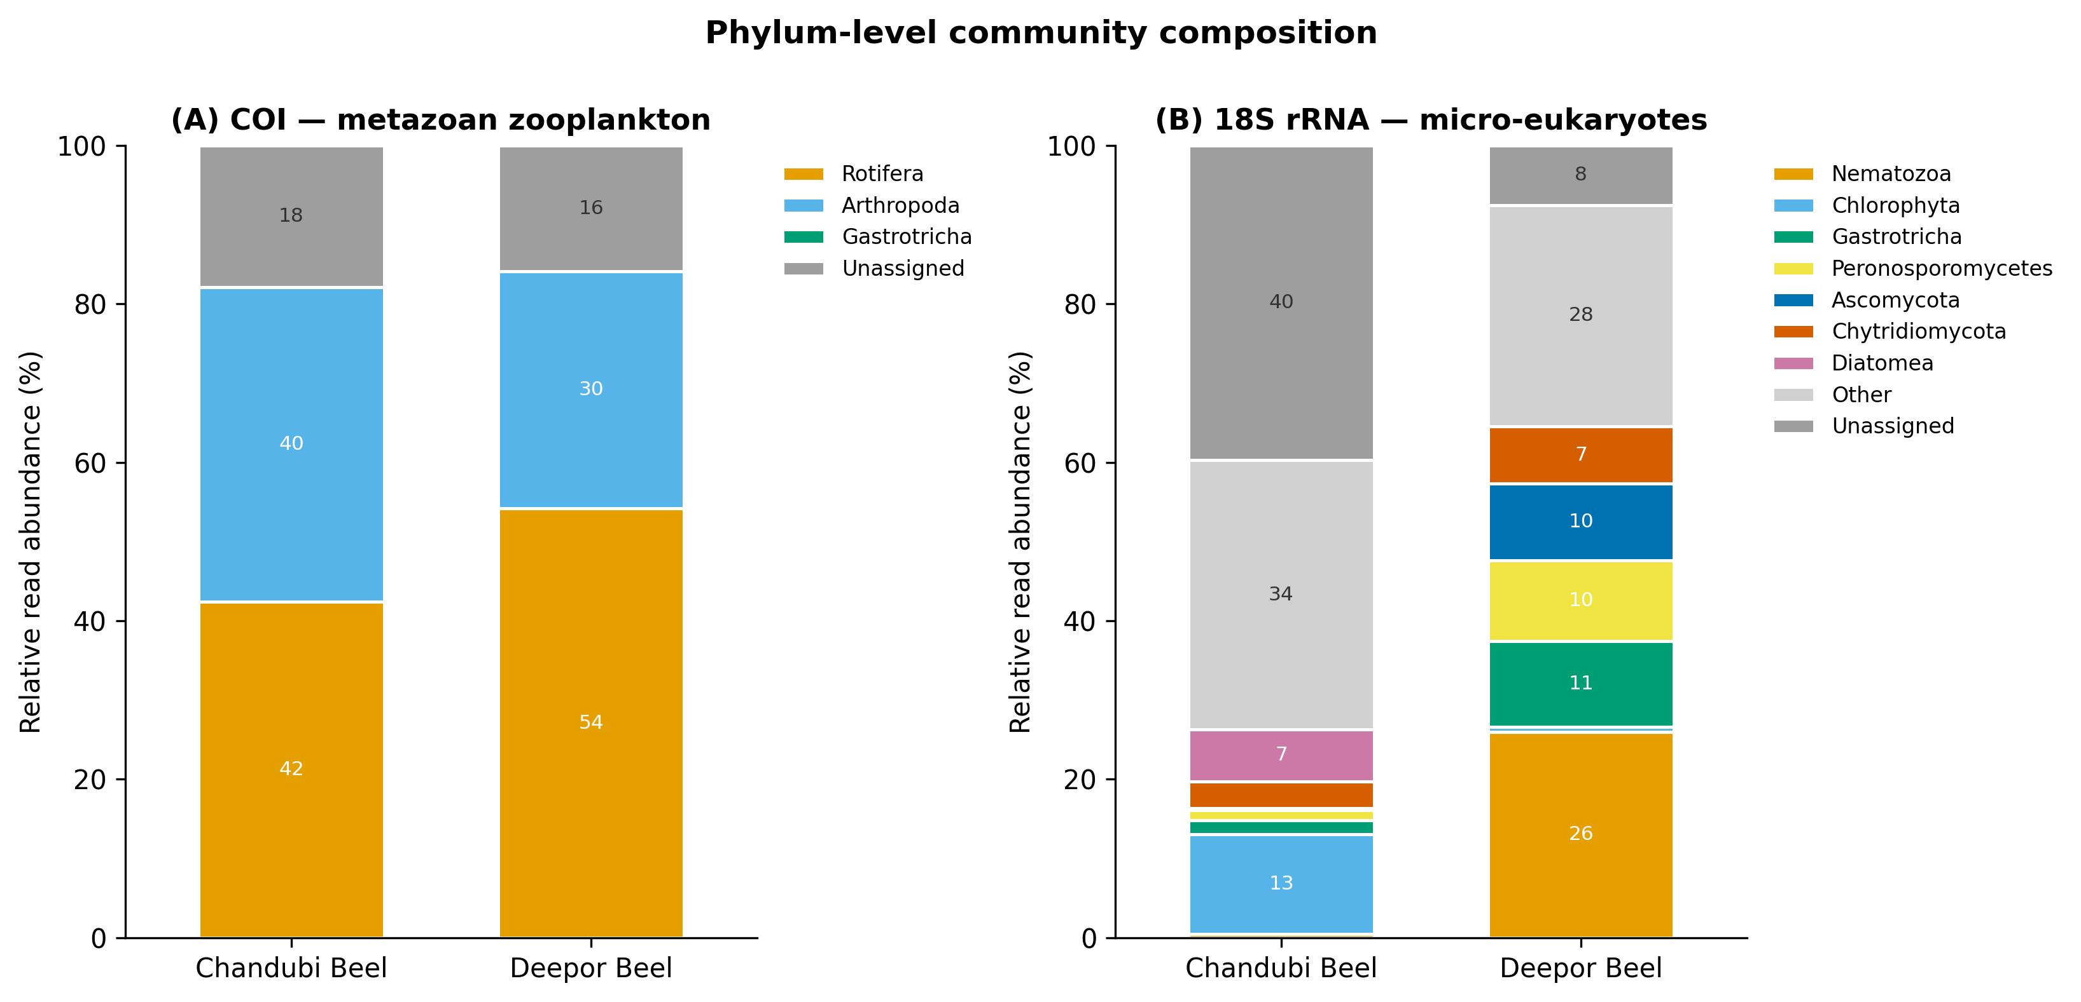
Figure 1. Phylum-level community composition for (A) COI and (B) 18S. Grey segments separate reads assignable only to a coarser rank ('Unassigned') from the pooled minor phyla ('Other').
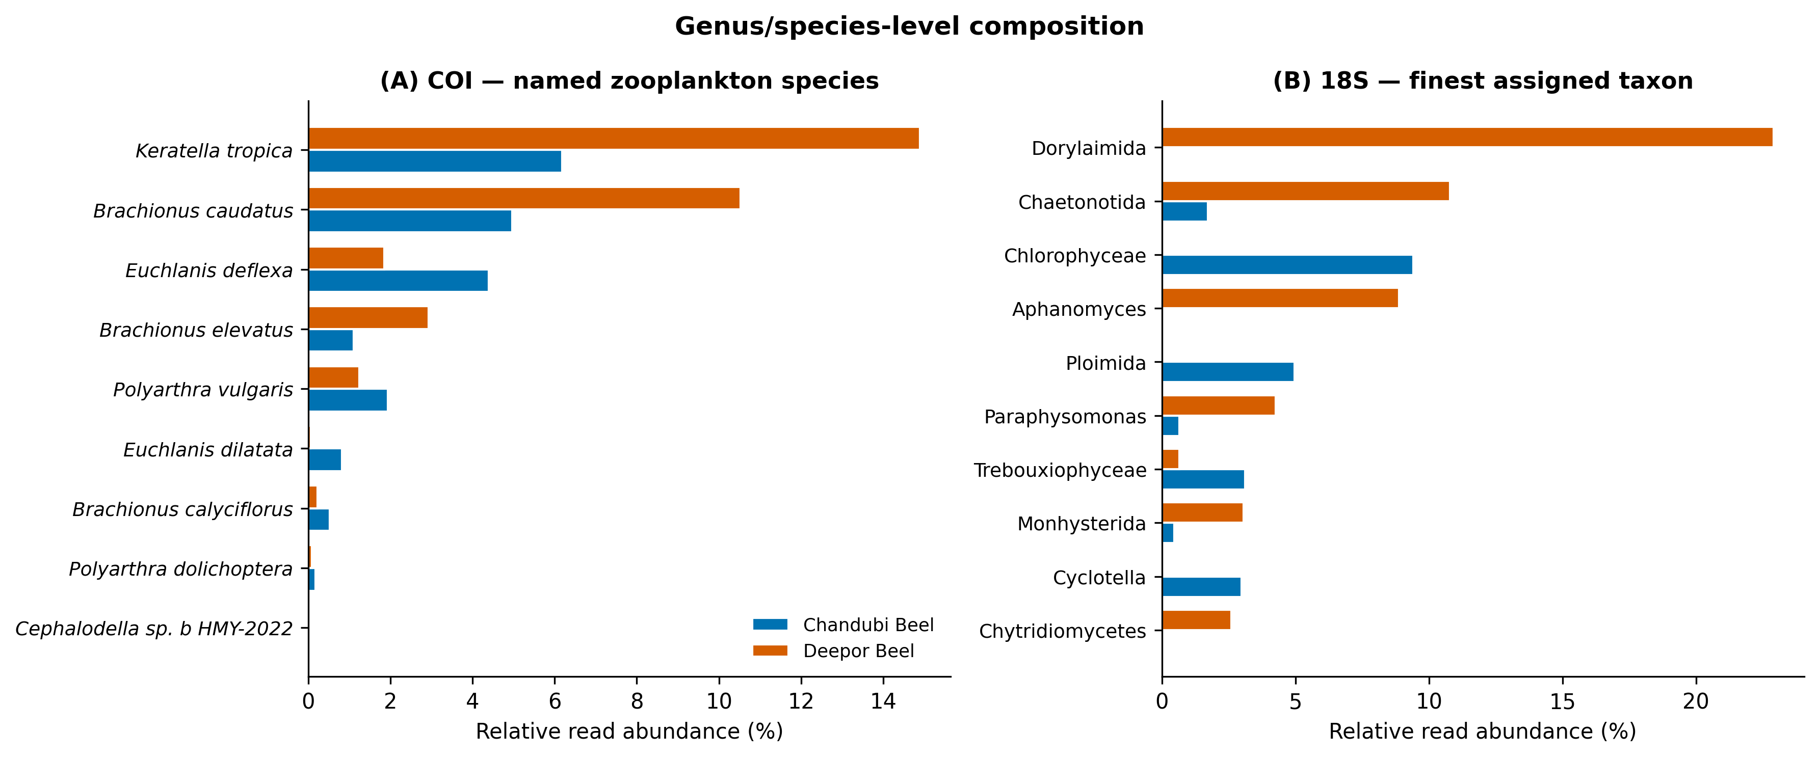
Figure 4. Finest-resolution composition. (A) Named COI zooplankton species — note the rise of the eutrophy indicators Keratella tropica and Brachionus caudatus at Deepor. (B) 18S taxa at their finest assigned rank; many 18S reads resolve only to order or class.

3.3 18S: micro-eukaryotes and trophic structure
The 18S marker exposed a difference between the two wetlands that COI could not see. At Chandubi the assemblage carried a clear primary-producer signal — green algae (Chlorophyta, ~13% of reads) and diatoms (Diatomea, ~7%) — with a large unassigned and minor-phyla fraction (Figure 1B). At Deepor the community was built on heterotrophs: nematodes alone (Nematozoa, largely order Dorylaimida) made up 26% of reads, with gastrotrichs (11%), oomycetes (Peronosporomycetes, 10%, including the fish/crustacean pathogen genus Aphanomyces), sac fungi (Ascomycota, 10%) and chytrid fungi (7%) filling most of the rest.
Grouped by broad trophic role, the contrast is stark (Figure 3). Photoautotrophs accounted for a quarter of the Chandubi micro-eukaryote reads but only a tenth at Deepor, while metazoa rose from 9% to 41% and fungi from 9% to 18%. A wetland whose micro-eukaryote signal is dominated by nematodes, fungi and oomycetes rather than algae is one running more on decomposition than on primary production — a profile consistent with organic enrichment, though a single sample cannot establish that.
Table 4. 18S rRNA composition: dominant phyla and broad functional groups (% of reads).
Group | Chandubi (%) | Deepor (%)
Photoautotrophs (algae: Chlorophyta, Diatomea, Ochrophyta, Dinoflagellata) | 24.6 | 10.4
Heterotrophic protists (Ciliophora, Cercozoa, Protalveolata, others) | 15.6 | 23.8
Fungi (Ascomycota, Chytridiomycota, Cryptomycota, oomycetes) | 9.3 | 17.5
Metazoa (Nematozoa, Gastrotricha, Rotifera, Arthropoda) | 9.0 | 40.8
Other / unassigned | 41.5 | 7.5
— Nematozoa (phylum) | 0.5 | 26.0
— Gastrotricha (phylum) | 1.7 | 10.8
— Peronosporomycetes (oomycetes) | 1.3 | 10.2
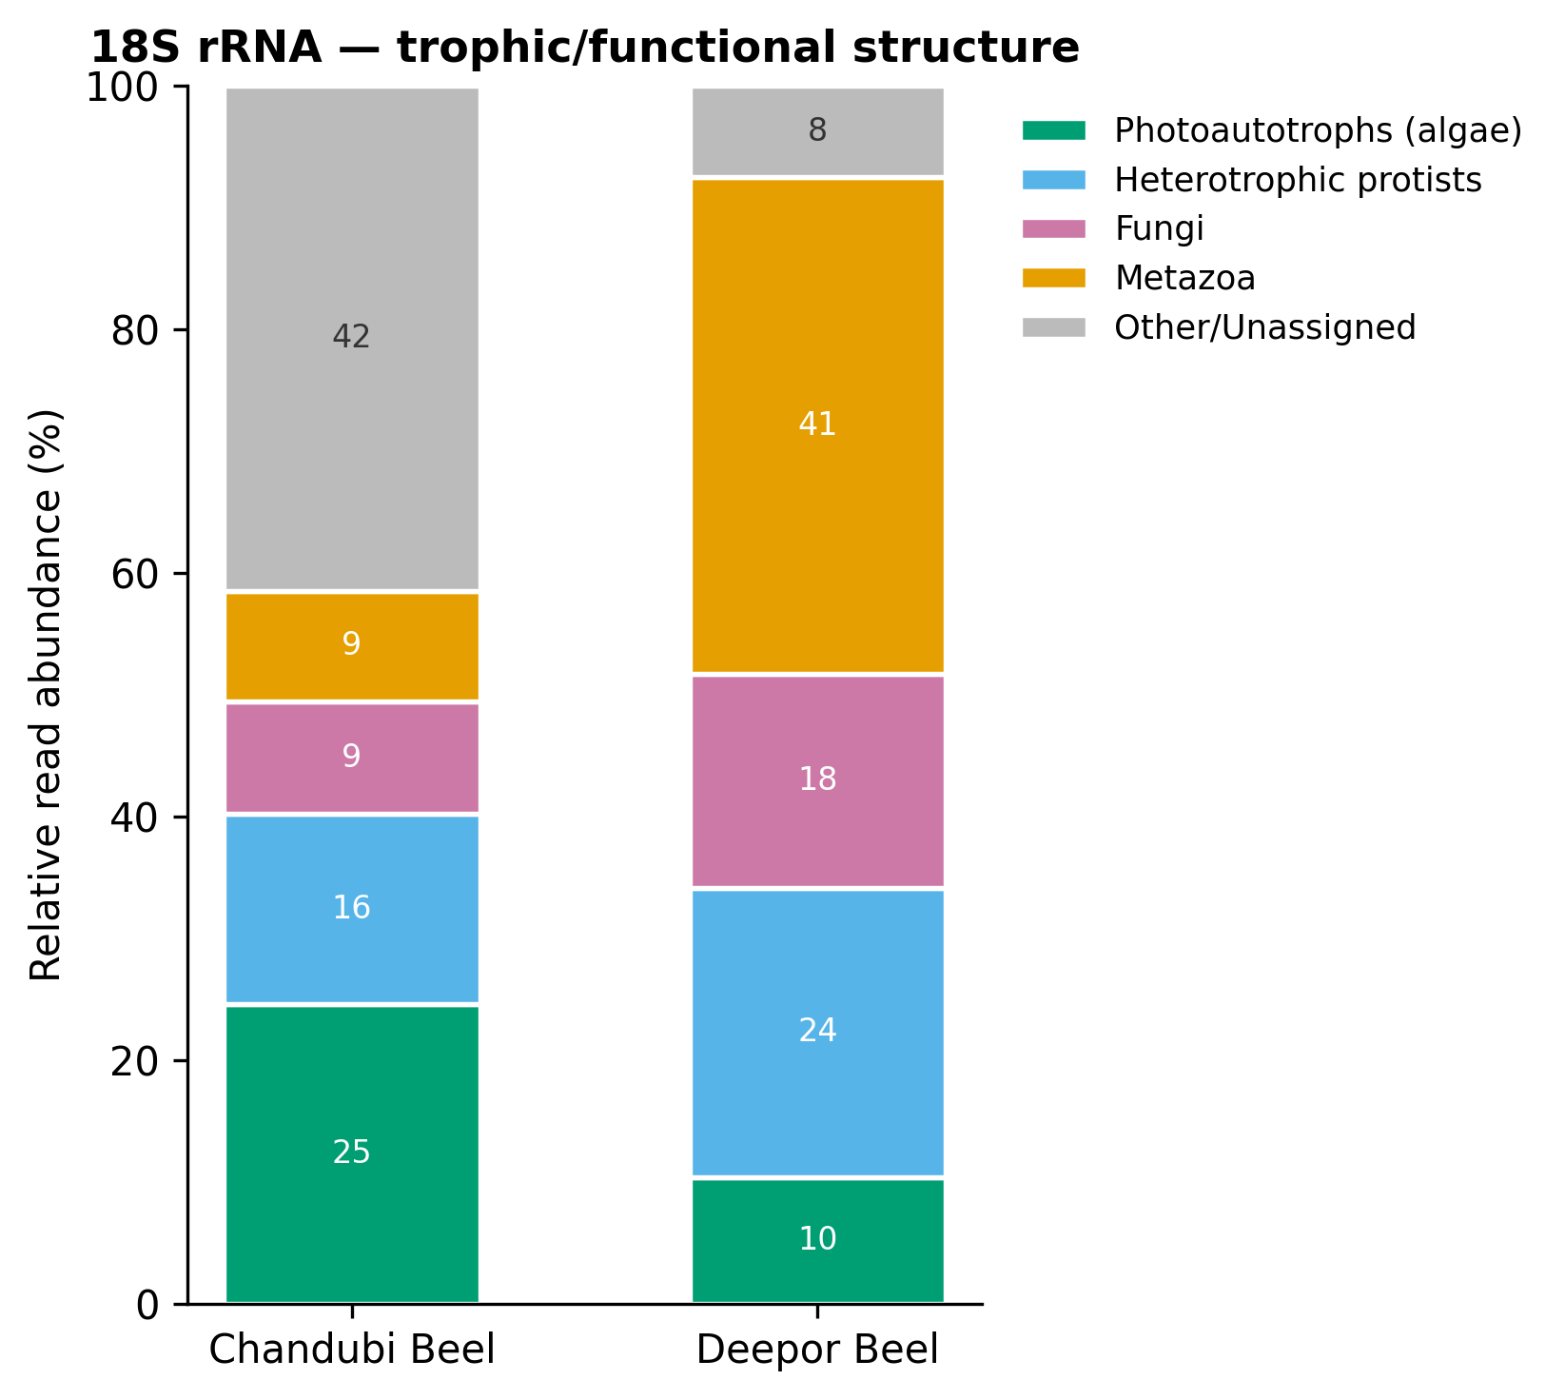
Figure 3. Trophic structure of the 18S micro-eukaryote community. Chandubi Beel retains a substantial algal (photoautotroph) fraction; Deepor Beel is dominated by heterotrophs — metazoa, fungi and heterotrophic protists.

3.4 Shared and site-exclusive taxa, and community turnover
The two markers disagreed about how similar the wetlands are, and the disagreement is informative. For COI, the zooplankton communities overlapped strongly: eight named species were common to both sites, with only two exclusive to Chandubi and one to Deepor (Jaccard 0.73; Figure 5A). Genus-level Bray–Curtis dissimilarity was 0.22 and Morisita–Horn only 0.04 — by abundance, the two rotifer assemblages are nearly the same community shifted in proportion. For 18S the opposite held: just two named species were shared, against 25 exclusive to Chandubi and 11 to Deepor (Jaccard 0.05; Bray–Curtis 0.77; Figure 5B). The micro-eukaryote assemblages are, in composition, largely different communities. Chandubi's exclusive taxa were led by diatoms (Cyclotella, Aulacoseira, Nitzschia) and green algae; Deepor's by nematodes, the oomycete Aphanomyces, testate amoebae (Arcella) and chytrid fungi.
One shared 18S species is worth singling out: Mesocyclops dissimilis, a cyclopoid copepod. Copepods and cladocerans were absent from the COI-identified fraction at both sites — not rare, absent — which is not credible for tropical floodplain wetlands and instead points to poor COI reference coverage for Indian freshwater crustaceans. That 18S recovered a copepod the COI reference could not place is the clearest single argument in this dataset for using more than one marker.
Table 5. Taxon overlap between wetlands (named taxa) and descriptive compositional dissimilarity (genus level).
Marker | Rank | Shared | Chandubi-only | Deepor-only | Jaccard | Bray–Curtis
COI | genus | 3 | 2 | 1 | 0.50 | 0.22
COI | species | 8 | 2 | 1 | 0.73 | —
18S | genus | 11 | 32 | 20 | 0.18 | 0.77
18S | species | 2 | 25 | 11 | 0.05 | —
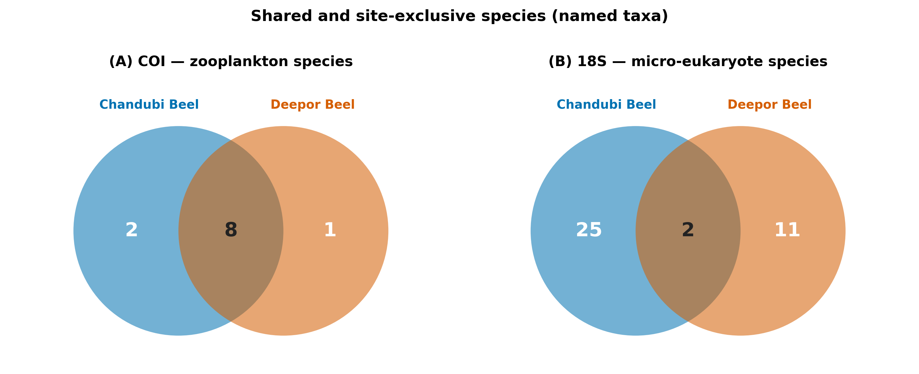
Figure 5. Shared and site-exclusive named species. (A) COI zooplankton overlap heavily; (B) 18S micro-eukaryotes barely overlap.
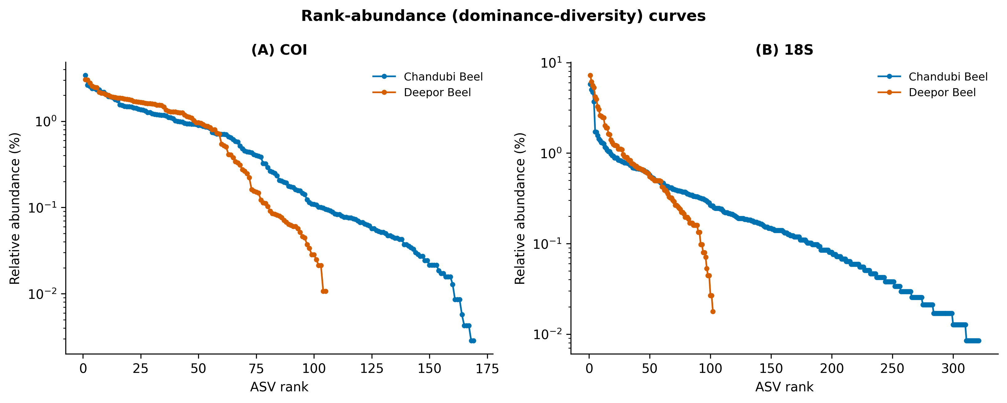
Figure 6. Rank-abundance (dominance–diversity) curves. All four assemblages show a short head of dominant taxa and a long, even tail; the Deepor 18S curve (B) falls off fastest, matching its lower inverse Simpson value.

4. Discussion
Read together, the two markers give a coherent reading of the two wetlands even though each sees a different part of the community. The zooplankton (COI) told a story of degree: the same rotifers run both beels, but Deepor tilts toward the eutrophy-associated Keratella tropica and Brachionus caudatus, which more than doubled their share there. Both are pantropical indicators of nutrient-rich water, and their enrichment at the Ramsar site fits its documented nutrient loading. I state that as consistency, not cause — one sample per lake cannot separate a real difference from sampling noise. The micro-eukaryotes (18S) told a story of kind: Chandubi retained an algal, primary-producer signal, while Deepor's community was built on nematodes, fungi and oomycetes. A shift from an autotroph-inclusive to a heterotroph-dominated micro-eukaryote profile is what one expects where organic matter accumulates and decomposition pathways take over, and the appearance of the oomycete Aphanomyces at Deepor is worth flagging on its own, given the genus includes serious fish and crustacean pathogens.
The clearest methodological result is that neither marker would have been enough. COI resolved rotifers to species and picked up the dominance shift, but its reference database could not place a single copepod or cladoceran — backbone taxa of tropical freshwater zooplankton — so roughly a third of its reads sat unassigned. 18S filled part of that gap, recovering the copepod Mesocyclops dissimilis and a broad protist, algal and fungal community, but it resolved many of those groups only to order or class. The pairing that works for this system is therefore COI for metazoan species resolution and 18S for breadth, a conclusion that matches multi-marker studies elsewhere (Zhang et al., 2018; Stefanni et al., 2018; Sildever et al., 2021; Zhao et al., 2021) and one that a third marker — the pending chloroplast 16S run — would extend to the phytoplankton, where 18S is weakest for functional resolution (Lemonnier et al., 2025). The unassigned COI fraction is not a dead loss either; BLAST comparison of those representative sequences against NCBI and BOLD would likely recover the missing crustaceans and is the obvious next analytical step (Chen et al., 2025).
Placed against the wider literature, the Deepor pattern echoes what eDNA surveys of pressured waterbodies elsewhere have found — a phytoplankton and micro-eukaryote community that reorganises under anthropogenic nutrient input (Lin et al., 2023) — and the two-wetland, reference-versus-impacted design mirrors recent lake and reservoir eDNA comparisons (Jo et al., 2026). For northeast India specifically, molecular plankton data barely exist, so even a descriptive inventory of these two beels adds to a nearly empty regional record (Sahu et al., 2025). The molecular species lists can also be read against the older morphological surveys of Deepor Beel [regional refs — to verify], and that comparison, marker by marker, is often the most useful part of such work.

4.1 Limitations
The design bounds what can be claimed. With one sample per wetland there is no replication, so no between-site difference here is tested for significance; every contrast is descriptive. Read counts index relative, not absolute, abundance — copy number, body size and primer affinity all bias recovery, so a rotifer-heavy read profile is not a rotifer-heavy biomass. The two samples of each marker were denoised separately, which makes ASV-level comparison unreliable and is why all overlap and turnover here rest on assigned taxonomy rather than ASVs. No extraction or PCR blanks and no positive (mock-community) control were included in the delivery, so low-level contamination cannot be excluded, and the drifting insect and terrestrial signal in the COI data should be treated with that caveat. Finally, taxonomic resolution is only as good as the reference databases, which are demonstrably incomplete for Indian freshwater invertebrates. None of these undermines the value of the dataset as a baseline; they set the terms on which it should be read and point directly to the improvements — replication, seasonal sampling, controls, representative-sequence BLAST, and the third marker — that would turn this baseline into a test.

5. Conclusion
This is, to my knowledge, the first molecular plankton inventory of Deepor Beel and Chandubi Beel and the first side-by-side eDNA comparison of the two. Two markers give a two-part reading: a shared rotifer zooplankton that shifts toward eutrophy indicators at the pressured Ramsar site, and a micro-eukaryote community that reorganises from an algal to a heterotroph-dominated profile between the reference and the impacted wetland. Both patterns are consistent with Deepor's known condition without, on one sample per site, proving it. The dataset stands as a reference point for these two wetlands and as the groundwork for the seasonal, replicated, multi-marker study that would let the differences be tested rather than described.

Data and code availability
Raw reads will be deposited in the NCBI Sequence Read Archive [accession pending]. Feature tables, per-sample taxonomy, the full analysis workbook and the figure-generation code are available from the author. [Add repository/DOI.]

Author contributions, funding, acknowledgements
S.S. designed the study, analysed the data and wrote the manuscript. [Add co-authors and their contributions if any.] Funding: [ ]. Acknowledgements: [ sequencing provider Eurofins; field and laboratory assistance ].

References
1. Chen X, Yan Z, Li S, Yao M (2025). Advancing aquatic biodiversity assessments of invertebrates using eDNA metabarcoding: a systematic evaluation of primers for marine and freshwater communities. Methods in Ecology and Evolution. https://doi.org/10.1111/2041-210X.70152
2. Jo GY, Suman TY, Ji CW, Hong C, Park YS, Kong DS, Kwak IS (2026). Seasonal and spatiotemporal dynamics of plankton communities using eDNA metabarcoding in Singal Reservoir. Environmental Management 76(3): 92. https://doi.org/10.1007/s00267-025-02357-1
3. Lemonnier C, Alric B, Domaizon I, Rimet F (2025). Comparison of metabarcoding and shotgun sequencing confirms the relevance of chloroplastic rRNA genes to assess community structure of lake phytoplankton. Molecular Ecology Resources. https://doi.org/10.1111/1755-0998.70077
4. Leray M, Yang JY, Meyer CP, Mills SC, Agudelo N, Ranwez V, Boehm JT, Machida RJ (2013). A new versatile primer set targeting a short fragment of the mitochondrial COI region for metabarcoding metazoan diversity. Frontiers in Zoology 10: 34. https://doi.org/10.1186/1742-9994-10-34
5. Lin Y, Zhong W, Zhang X, Zhou X, He L, Lv J, Zhao Z (2023). Environmental DNA metabarcoding revealed the impacts of anthropogenic activities on phytoplankton diversity in Dianchi Lake and its three inflow rivers. Ecology and Evolution 13(5): e10088. https://doi.org/10.1002/ece3.10088
6. Sahu A, Singh M, Laxmi RK, Shah TK, Sharma M (2025). Environmental DNA (eDNA): an eco-friendly approach for conservation of Indian freshwater diversity—a review. Environmental Science and Pollution Research 32(15). https://doi.org/10.1007/s11356-025-36202-z
7. Sildever S, Laas P, Kolesova N, Lips I, Lips U, Nagai S (2021). Plankton biodiversity and species co-occurrence based on environmental DNA – a multiple marker study. Metabarcoding and Metagenomics 5: e72371. https://doi.org/10.3897/mbmg.5.72371
8. Stefanni S, Stanković D, Borme D, de Olazabal A, Juretić T, Pallavicini A, Tirelli V (2018). Multi-marker metabarcoding approach to study mesozooplankton at basin scale. Scientific Reports 8: 12085. https://doi.org/10.1038/s41598-018-30157-7
9. Zhang GK, Chain FJJ, Abbott CL, Cristescu ME (2018). Metabarcoding using multiplexed markers increases species detection in complex zooplankton communities. Evolutionary Applications 11(10): 1901–1914. https://doi.org/10.1111/eva.12694
10. Zhao L, Zhang X, Xu M, Mao Y, Huang Y (2021). DNA metabarcoding of zooplankton communities: species diversity and seasonal variation revealed by 18S rRNA and COI. PeerJ 9: e11057. https://doi.org/10.7717/peerj.11057

Regional references to add and verify before submission
The following morphology-based Deepor Beel studies are needed for the site description and species comparison. Titles/journals are from database listings; confirm authors, volume and pages before citing (no DOIs located).
• Zooplankton communities of Deepor Beel (a Ramsar site), Assam (N.E. India): ecology, richness and abundance. Tropical Ecology 52(3): 293–302 (2011).
• Phytoplankton diversity of Deepor beel — a Ramsar site and floodplain lake of the Brahmaputra basin, Assam. Indian Journal of Fisheries 62(1): 33–40 (2015).
• Algal diversity in Deepor Beel of Assam: a Ramsar site of North East India. Nelumbo (Bulletin of the Botanical Survey of India), 2021.

